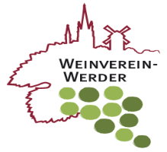
DRAFT AGENDA
10th – 12th October 2014
Study visit Werder (Havel) GERMANY

Friday 10th October
Arrivals - Hotel zur Insel www.hotel-zur-insel.de
18:45 meeting at the hotel – lobby, walk to restaurent (5‘)
19:00 Welcome dinner at the restaurant www.scharfrichter-werder.de

Saturday 11th October
9:15 Departure to Potsdam
10:30 Study visit Phöbener Wachtelberg www.derkagelwit.de
13:00 Study visit Königlicher Weinberg Potsdam (Royal Wine yard)) www.koeniglicher-weinberg.de
14.15 Light Lunch
15:00 Study visit Weingut Klosterhof Töplitz www.weingut.toeplitz.de
17:00 Study visit Weinbau Lindicke www.werderaner-wachtelberg.de
19:00 Dinner

Sunday 12th October 2014
10:00 Presentation about wine + tourism in Werder region
11:15 Meeting / Free time
Departure

