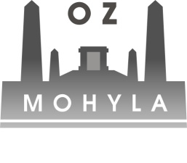
DRAFT AGENDA
8th – 10th August 2014 SLOVAKIA

Friday 8th August
Arrivals - Hotel YASMIN www.hotel-yasmin.sk
19:00 Welcome dinner at the hotel restaurant

Saturday 9th August
9:00 Departure to Tokaj (Veľká Tŕňa)
10:30 Study visit J & J Ostrožovič www.ostrozovic.sk
12:30 Study visit Tokaj Macik Winery (Malá Tŕňa) www.tokajmacik.sk
Presentation about wine tourism in Slovakia
13:30 Lunch
14:30 Wine cellar tour
16:00 Study visit Vino Vdovjak www.vinovdovjak.sk and Vinárstvo u Koňa (Veľká Tŕňa)
18:00 Study visit Zlatý strapec (Viničky) www.zlatystrapec.m3.sk
19:00 Dinner

Sunday 10th August 2014
9:00 Meeting / Free time
Departure

