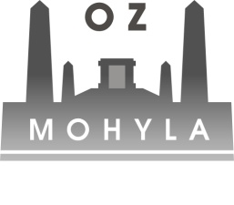
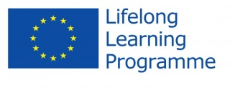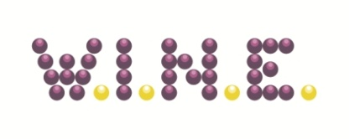
DRAFT AGENDA
5th – 7th June 2015 – Bratislava, SLOVAKIA

Friday 5.6.2015

Arrival at the Hotel Ibis Bratislava Centrum, Zámocká 38, 81101 Bratislava

19:00 Dinner (Zelený Rodrigéz)

Saturday 6.6.2015

9:00 Final report

13:00 Lunch

14:30 Final report

Free time

19:00 Dinner

Sunday 7.6.2015

Departure

